First we upload the cleaned files to our data lake

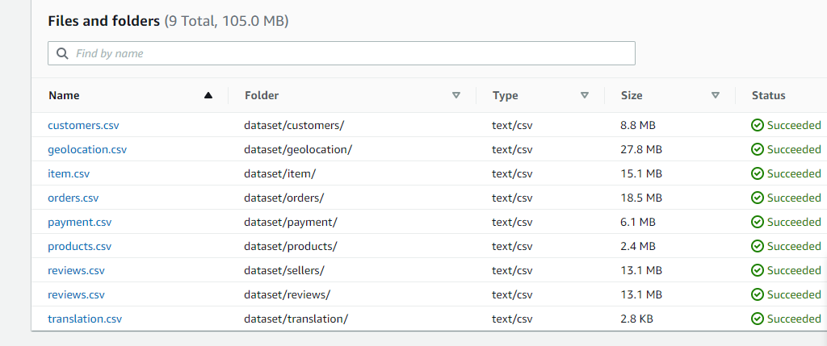

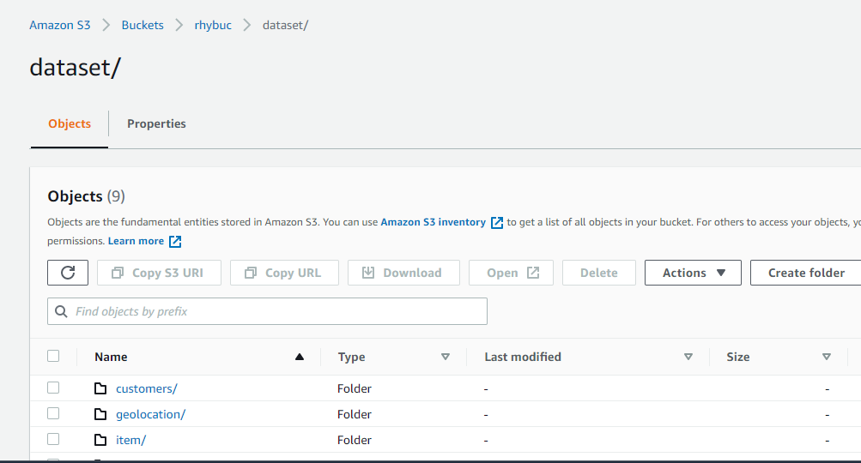

Make a crawler to crawl through all the files and make tables corresponding to them:

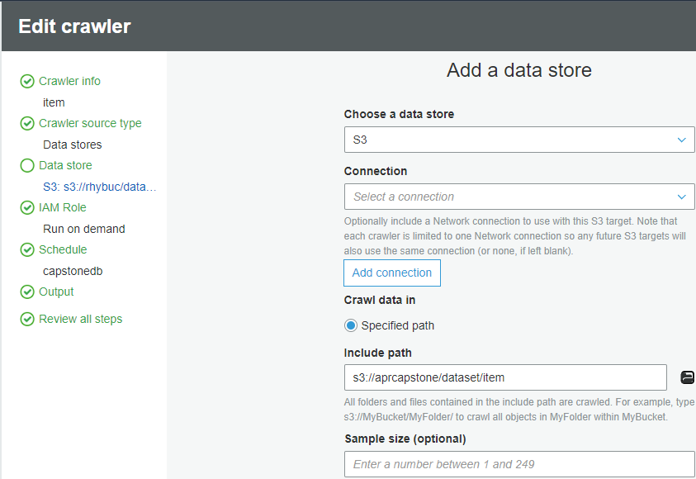

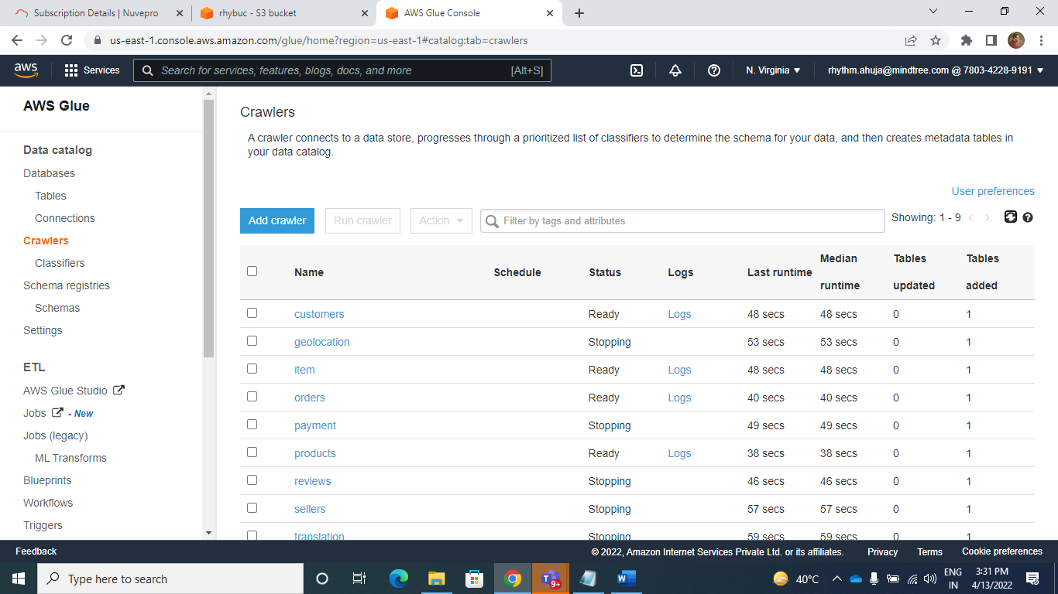

Run the crawlers and it makes the following tables:

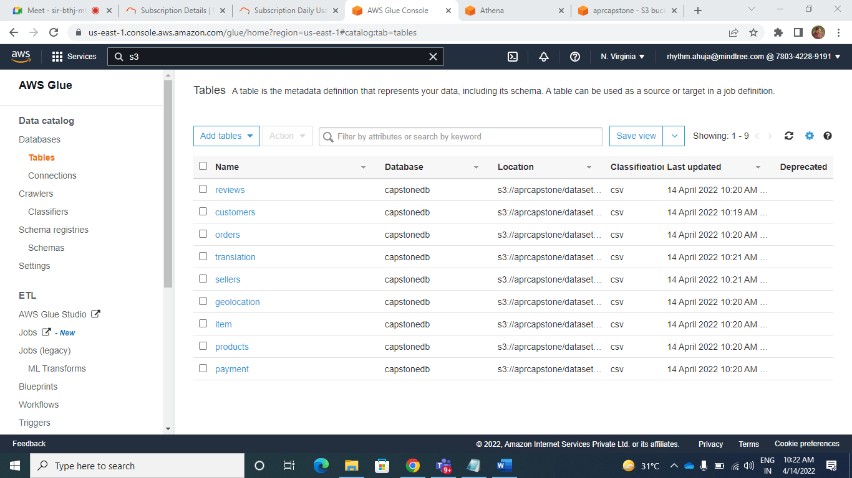

Now open Athena and run the following queries to get the desired outputs:

**[3]**.TOP SELLING PRODUCTS

select product_category_name, COUNT(product_category_name) as c from capstonedatabase."product" ,capstonedatabase."item"

where product.product_id=item.product_id

group by product_category_name

order by c

desc limit 1

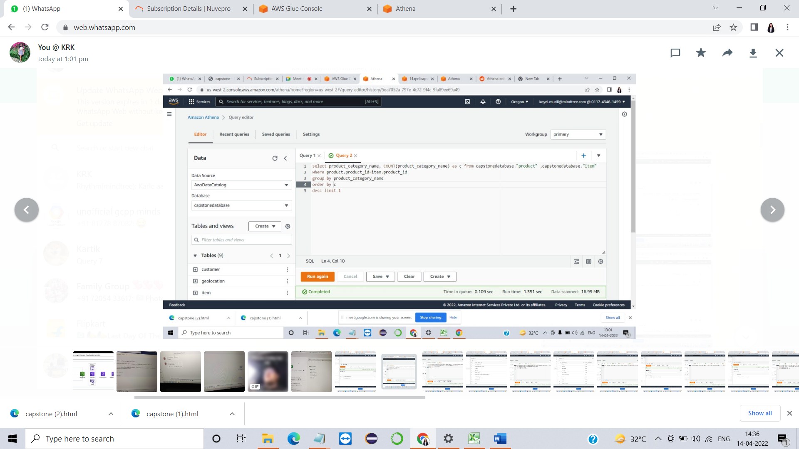

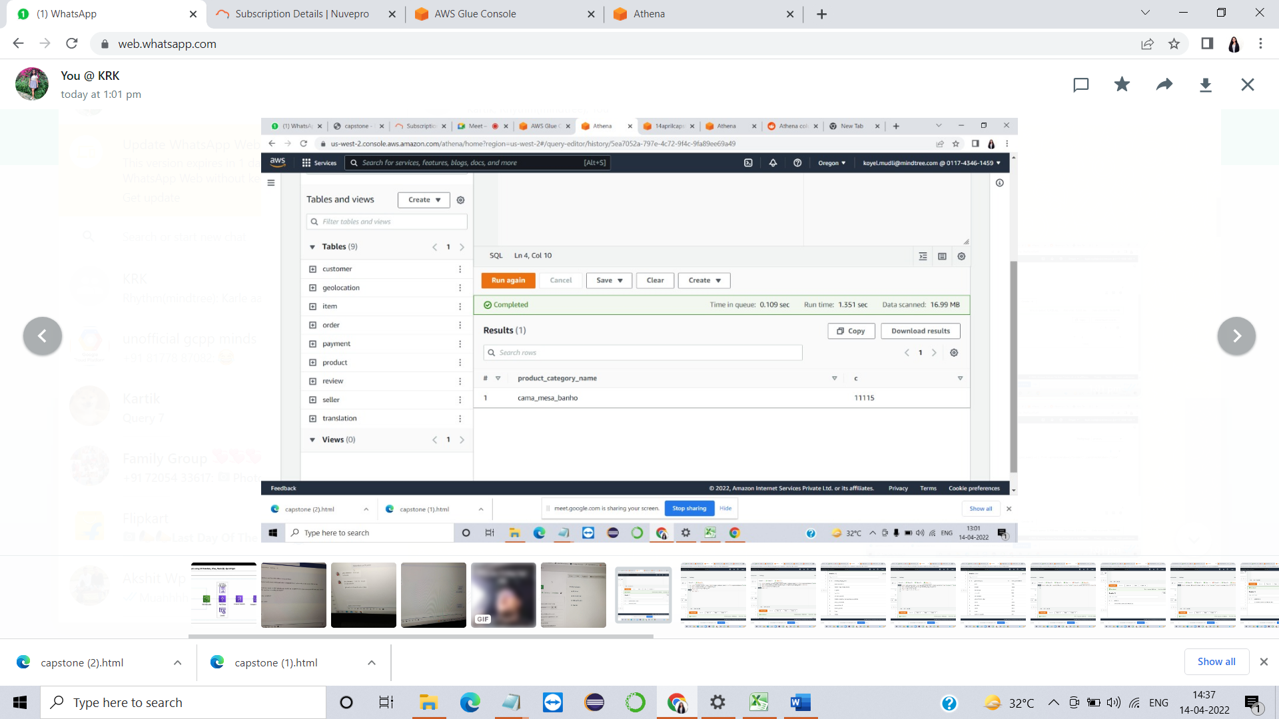

**[5]**.Total Orders by Category

select product_category_name, count(product_category_name) AS c from capstonedatabase."product", capstonedatabase."item"

where item.product_id=product.product_id and product_category_name is not null

group by product_category_name

order by c





**[6]**.Total Customer by Region

select geolocation_city, count(customer_unique_id) AS TOTAL_CUSTOMERS from "customer", "geolocation"

where customer_zip_code_prefix=geolocation_zip_code_prefix

group by geolocation_city

order by geolocation_city desc

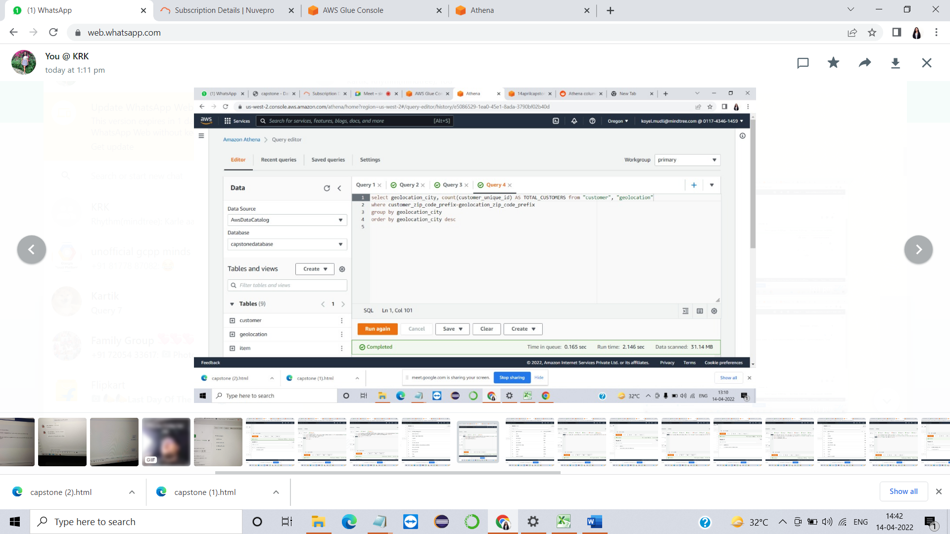

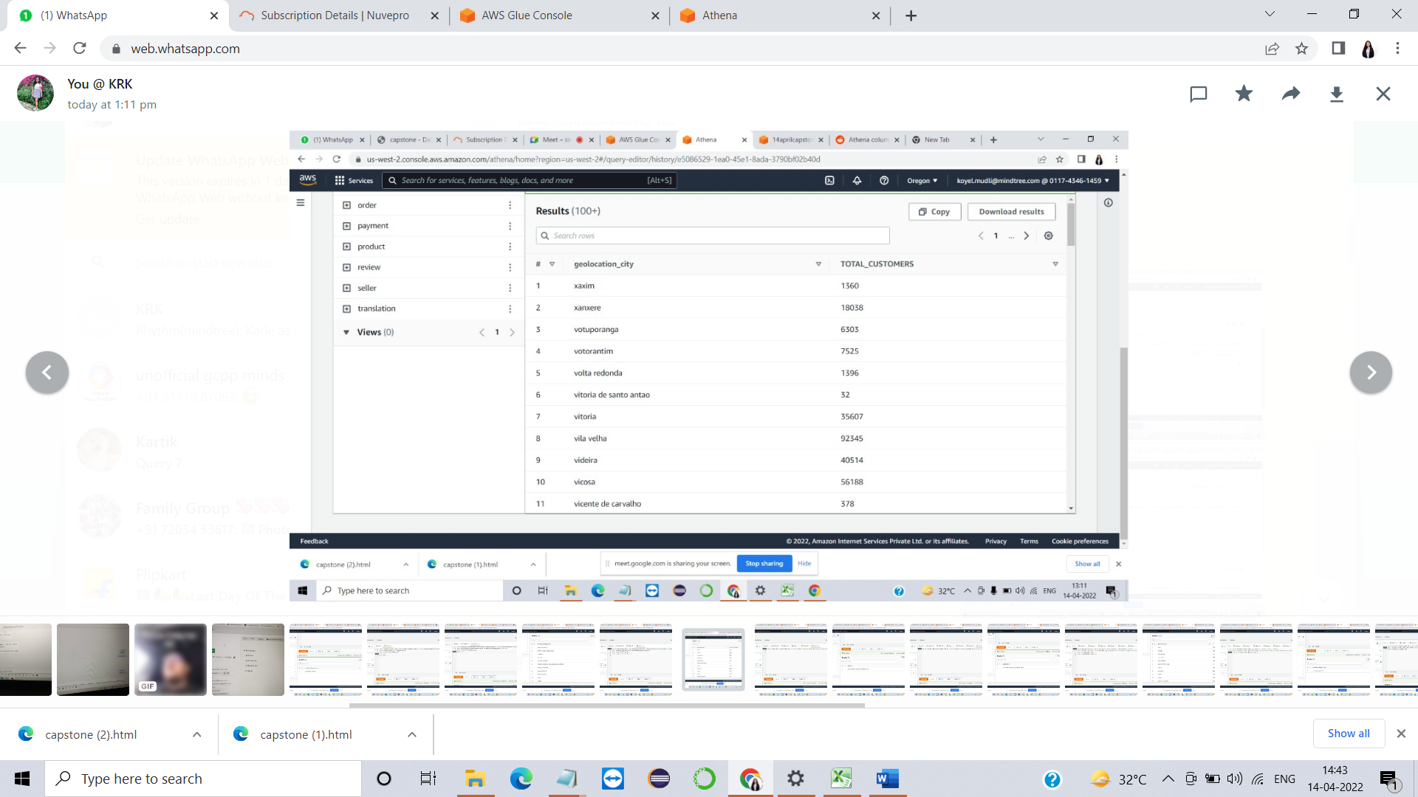

**[7]**.Annual Revenue

SELECT YEAR(order_purchase_timestamp),

SUM(revenue) AS annual_revenue

FROM (SELECT order_id,

ROUND(SUM(price) + SUM(freight_value),2) AS revenue

FROM [dbo].[item]

GROUP BY order_id) a

JOIN orders o

ON a.order_id = o.order_id

WHERE order_status = 'delivered'

GROUP BY year(order_purchase_timestamp)

ORDER BY year(order_purchase_timestamp)

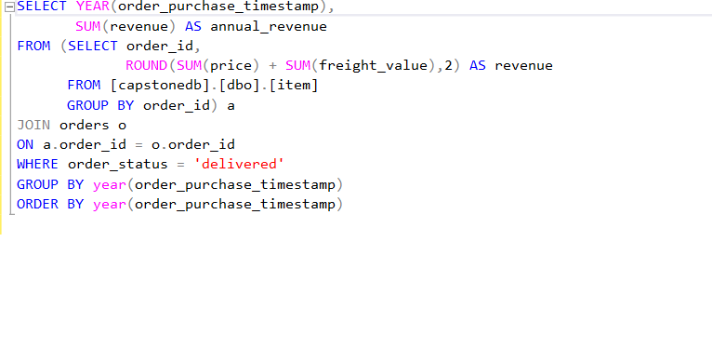 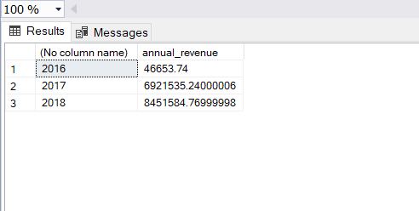

**Screenshot from local**

**[8]**.Most Valued Customer

select seller_id , count(seller_id) as c from "seller" group by seller_id order by c desc limit 1;

select customer_id,count(customer_id) as c from "customer" group by customer_id order by c desc limit 1;

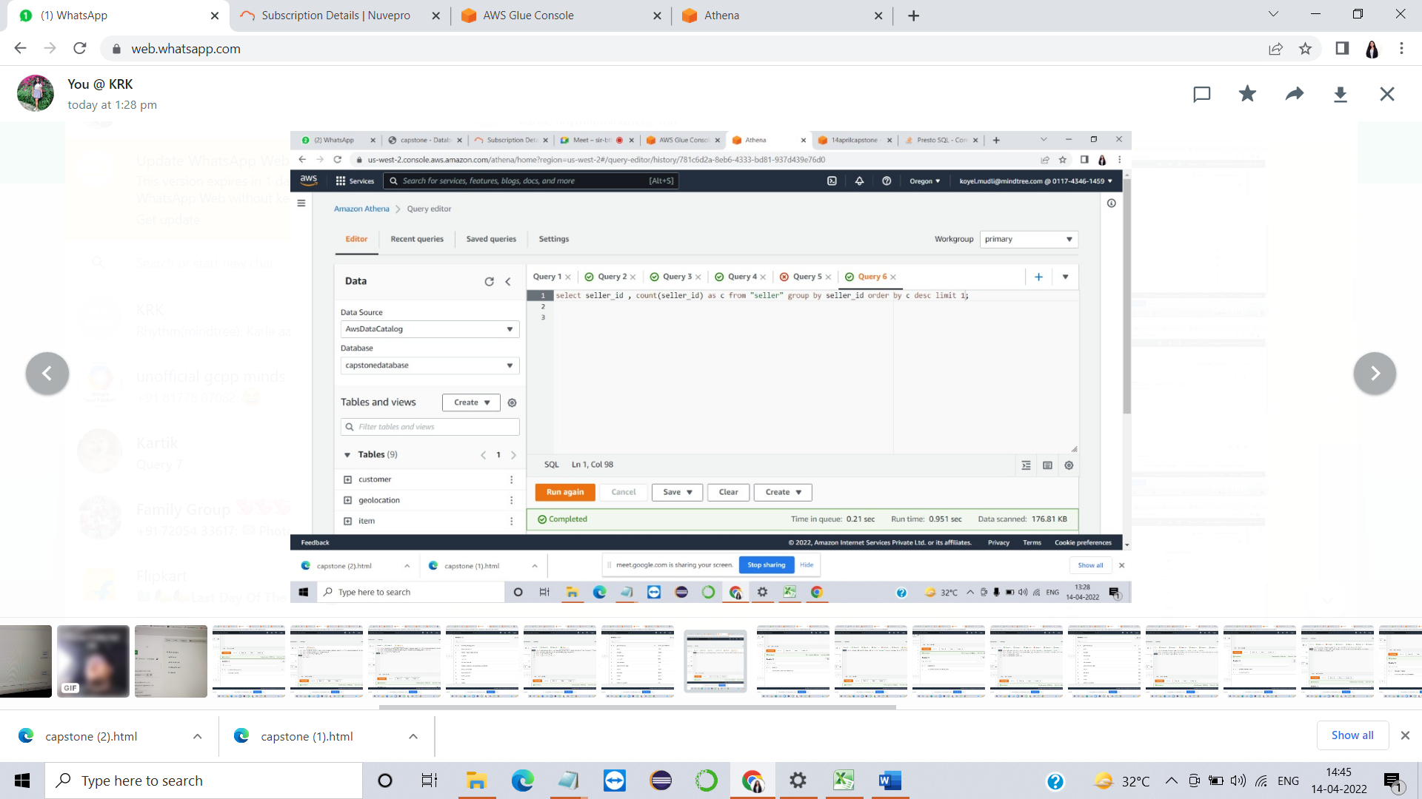

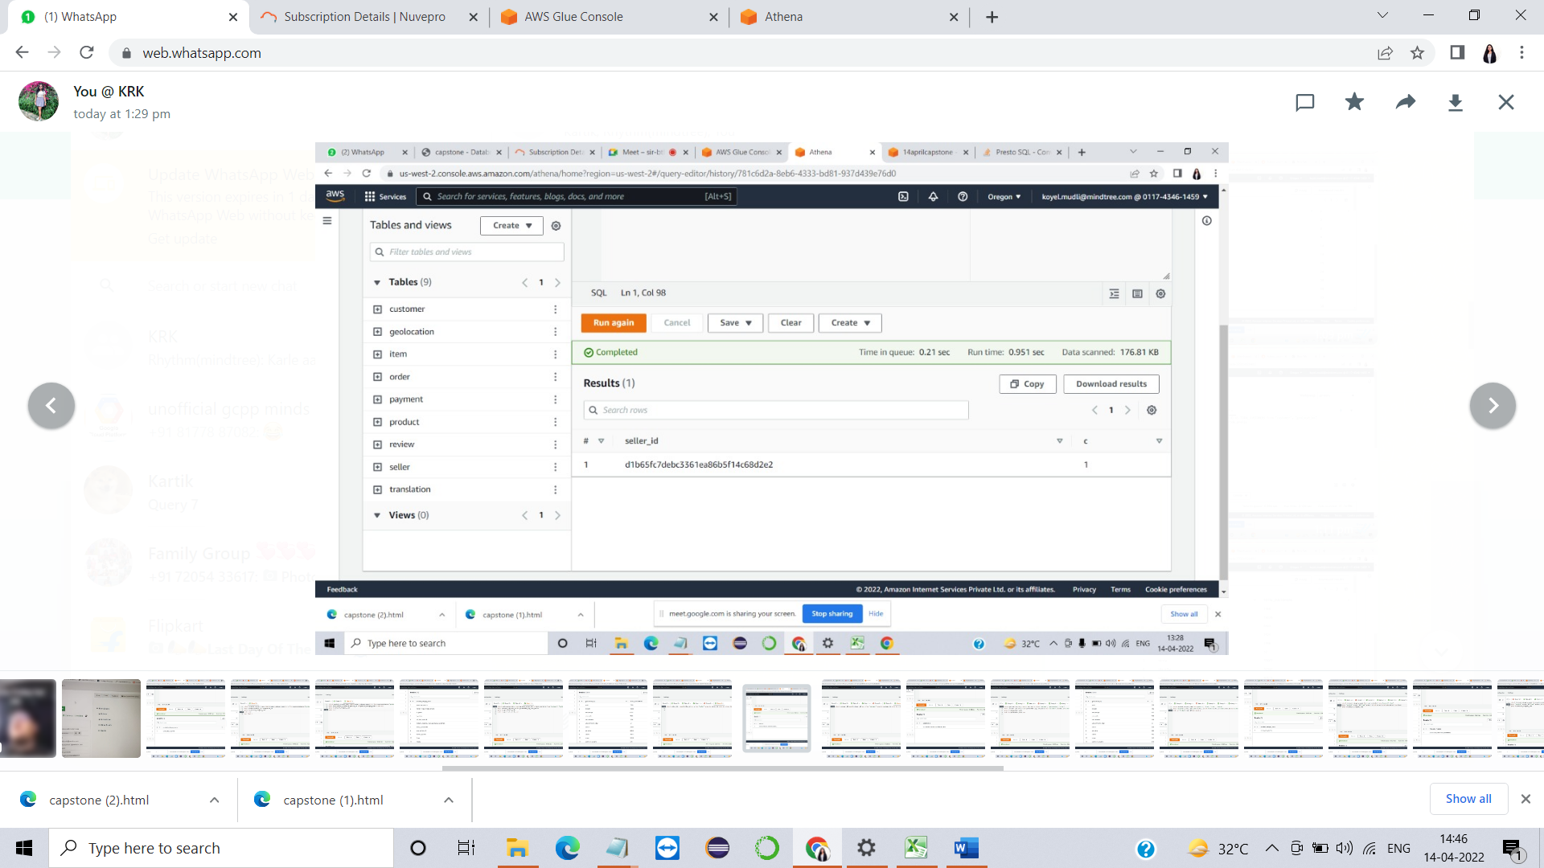

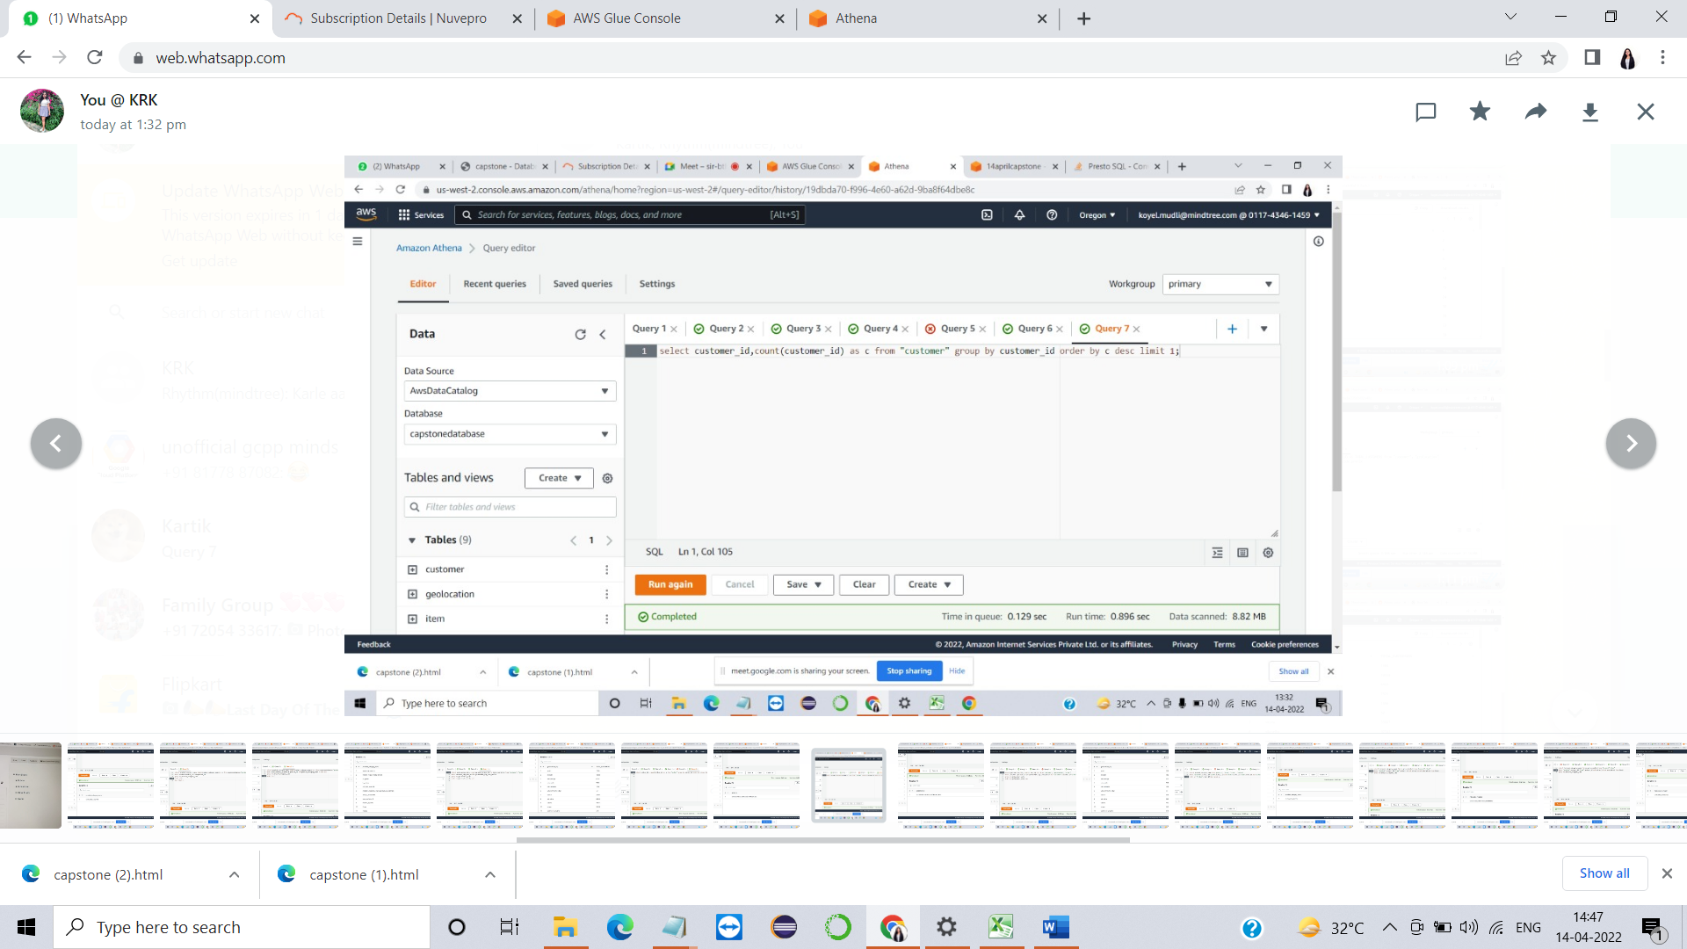

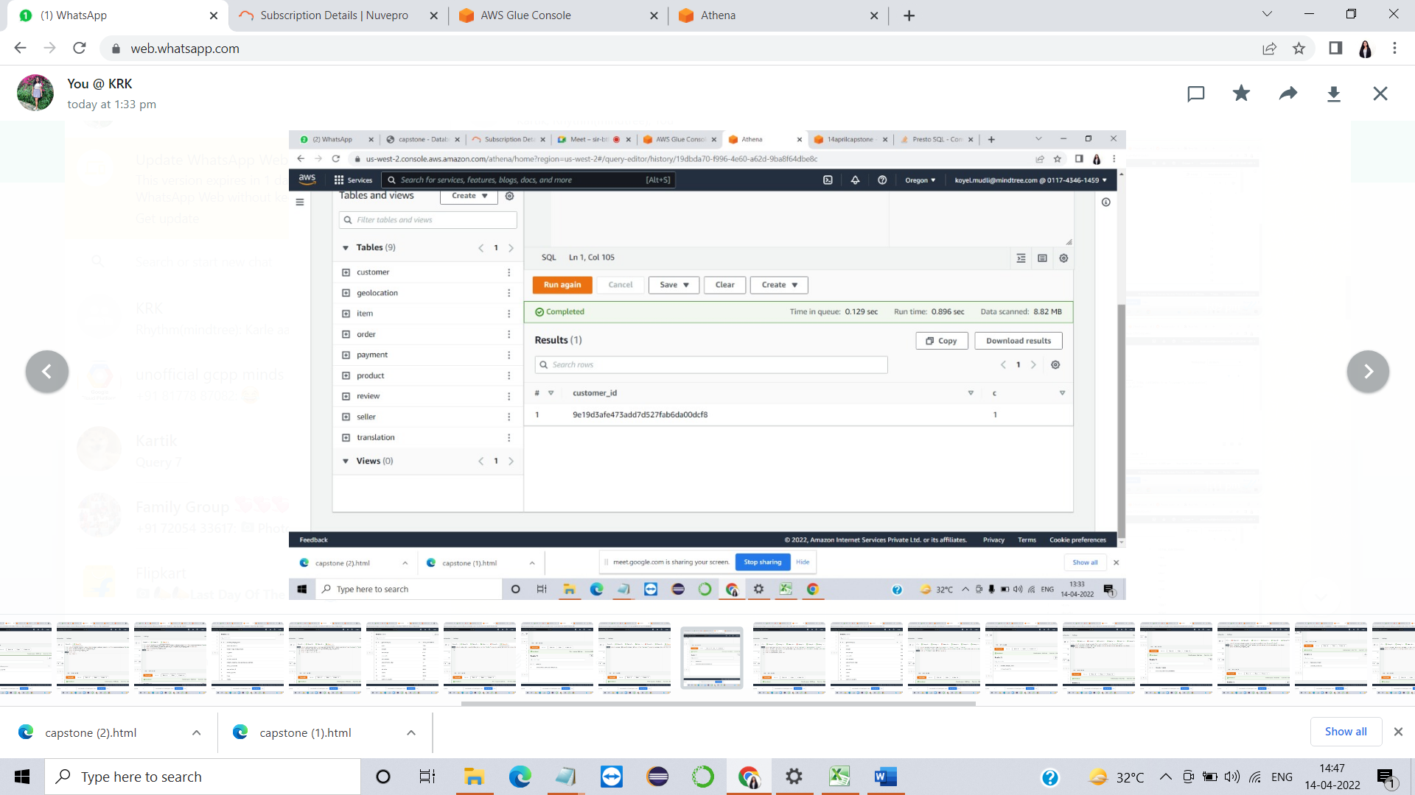

**[10]**.Total orders by regions/city

select geolocation_city, count(order_id) AS t from "customer", "geolocation", "order"

where customer_zip_code_prefix=geolocation_zip_code_prefix and "customer".customer_id="order".customer_id

group by geolocation_city

order by geolocation_city desc

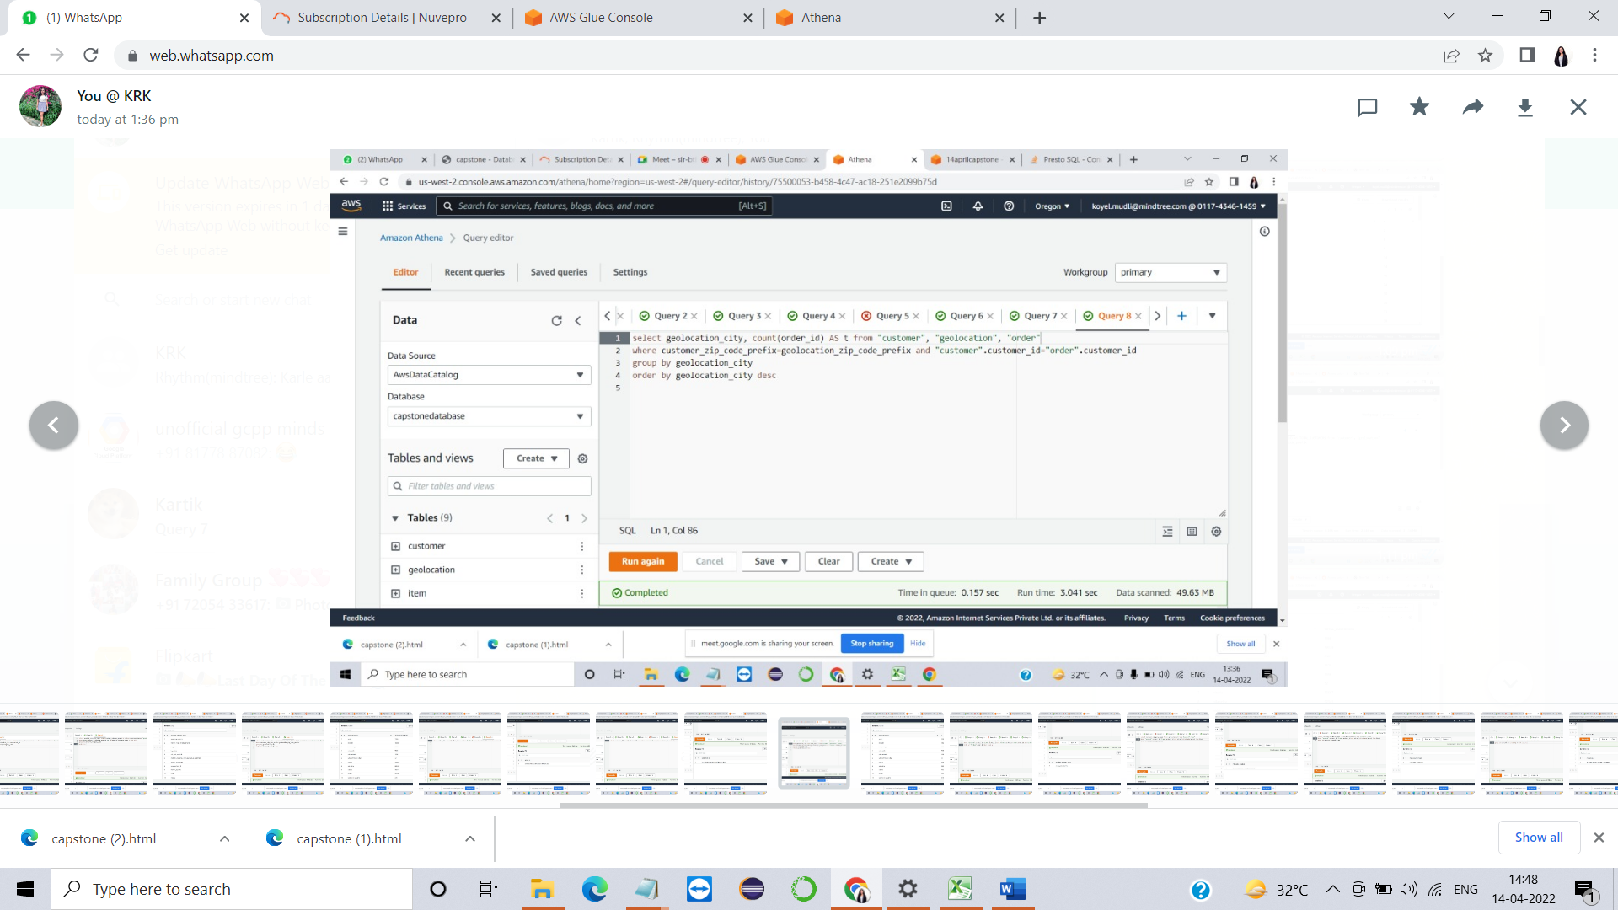

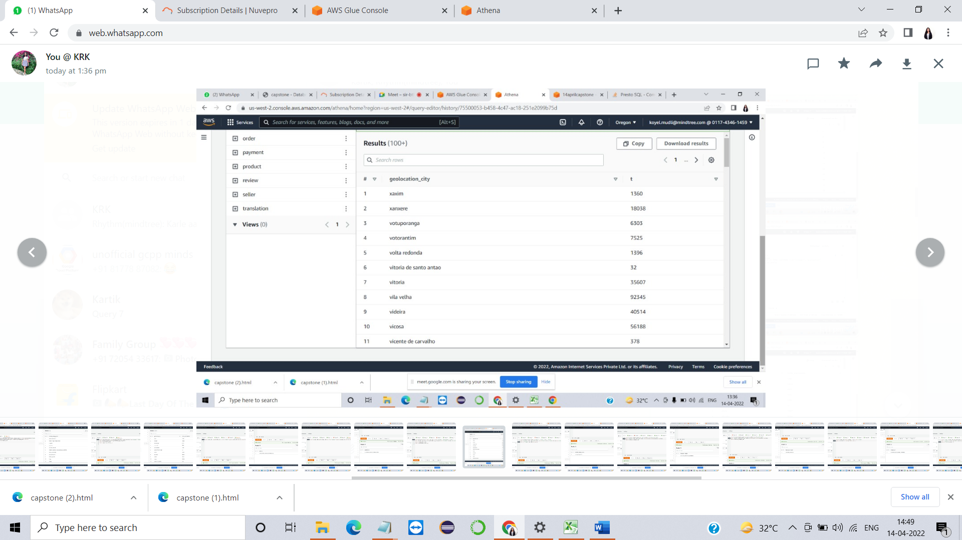

**[11]**.Most reviewed product

select product_category_name from "product", "item", "order", "review"

where "product".product_id="item".product_id and "order".order_id="item".order_id and "order".order_id="review".order_id

order by "review".order_id desc limit 1

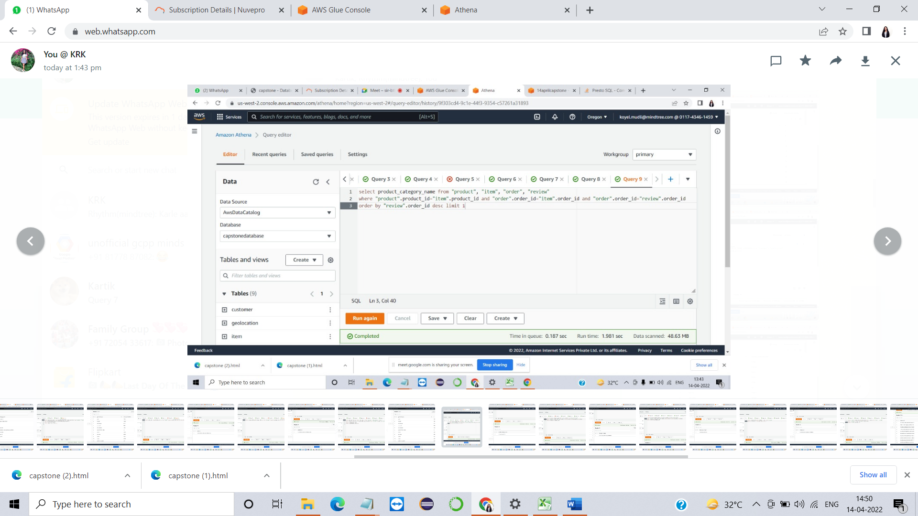

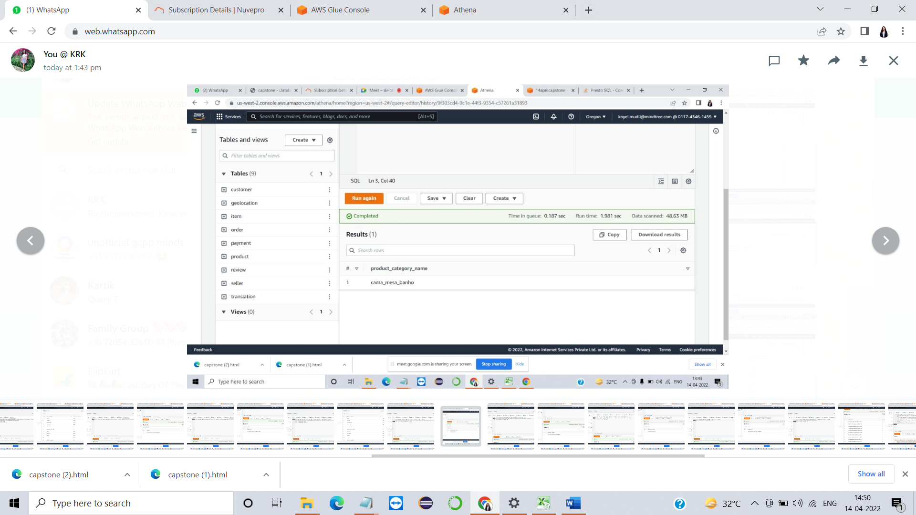

**[12]**.Minimum price product

select (product_category_name) AS Min_price_Product from "product","item"

where "product".product_id="item".product_id and price=(select min(price) from item)

group by product_category_name

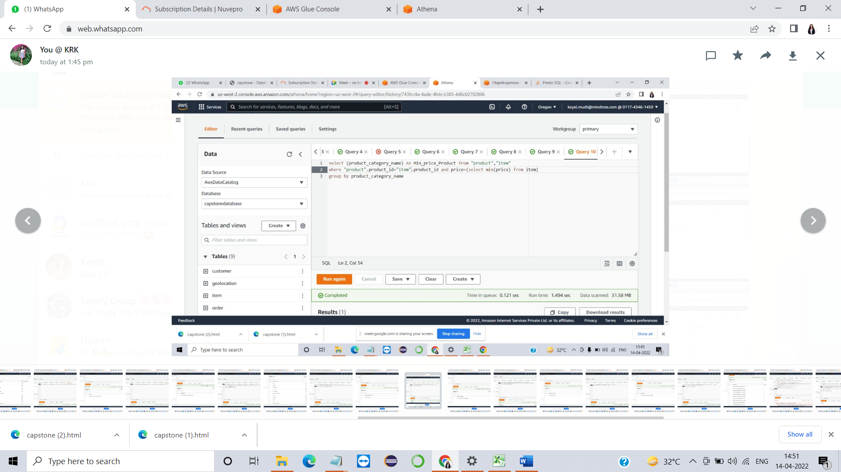

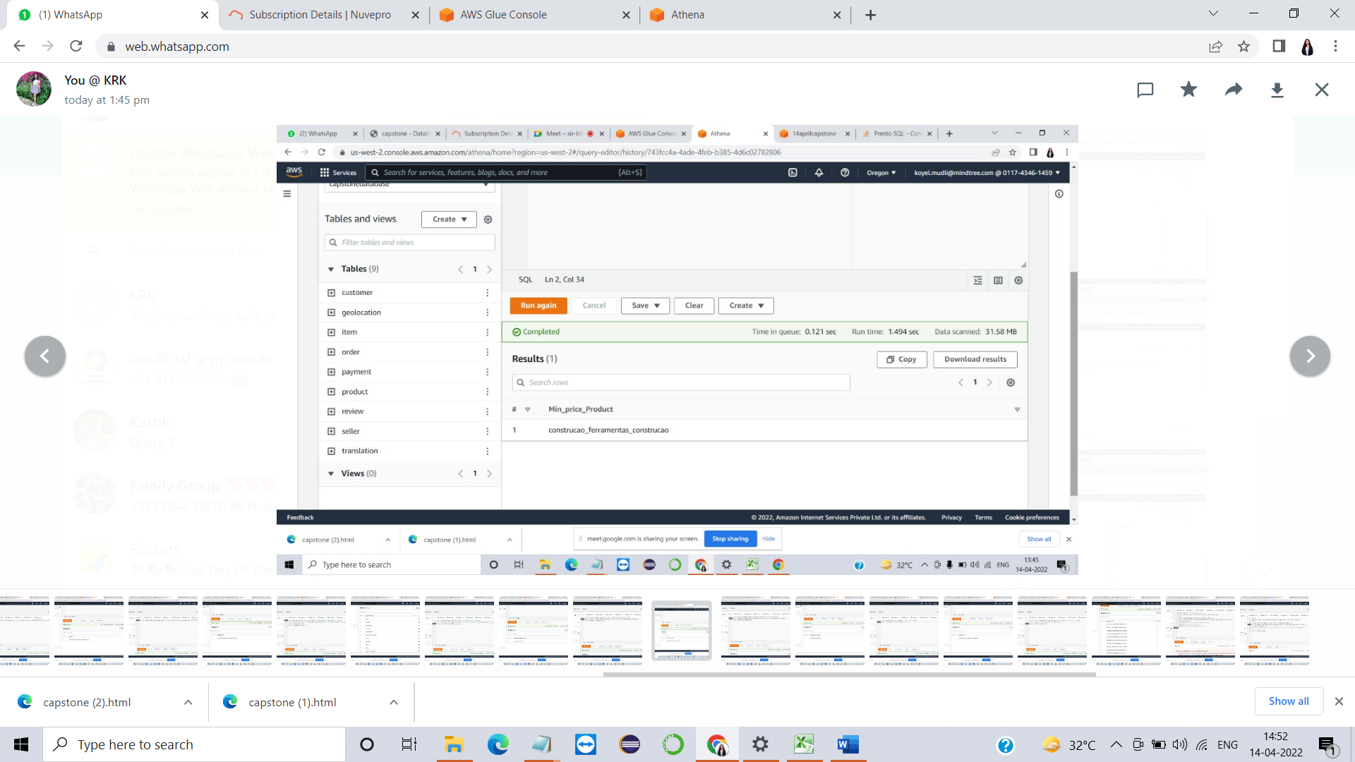

Maximum price product

select (product_category_name) AS MAX_price_product from "product","item"

where "product".product_id="item".product_id and price=(select max(price) from item)

group by product_category_name

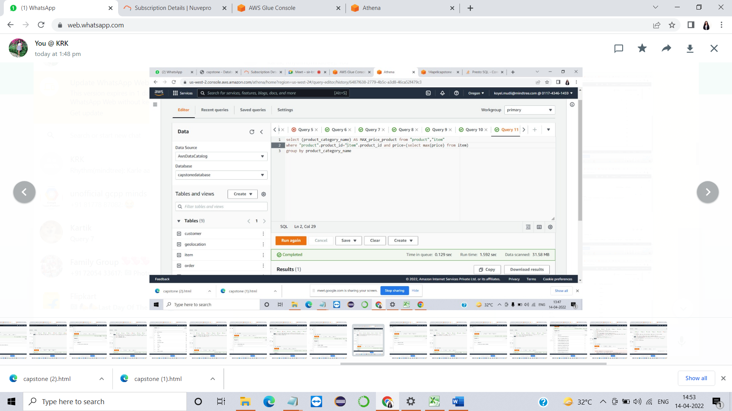

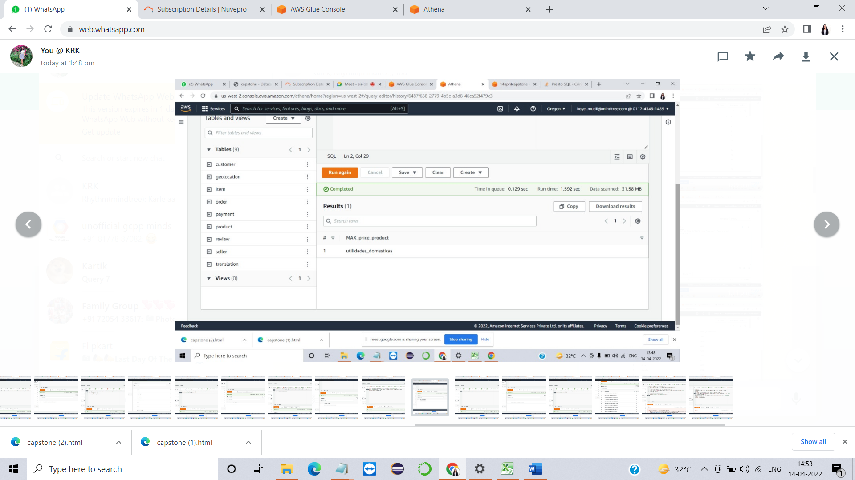

**[13]**.Returning Customers to understand Customer Loyalty

select customer_id, count(customer_id) AS c from "customer"

group by customer_id order by c desc limit 1

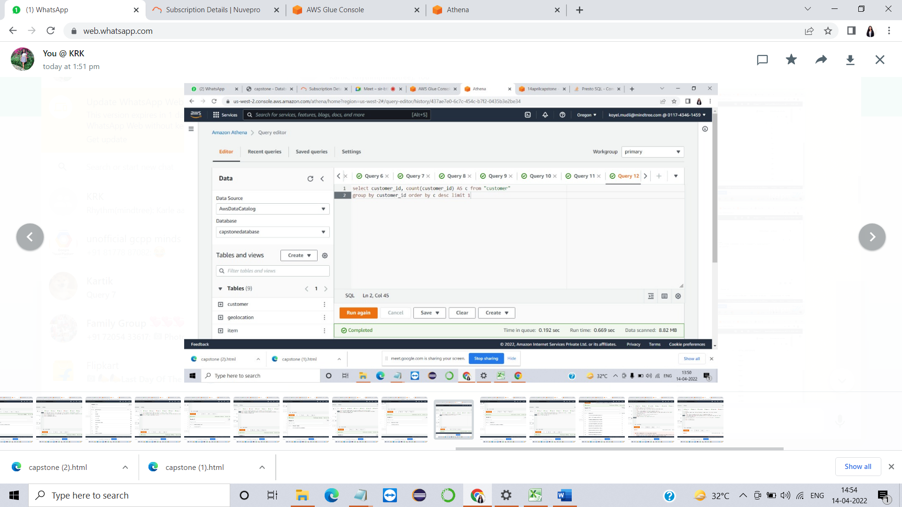

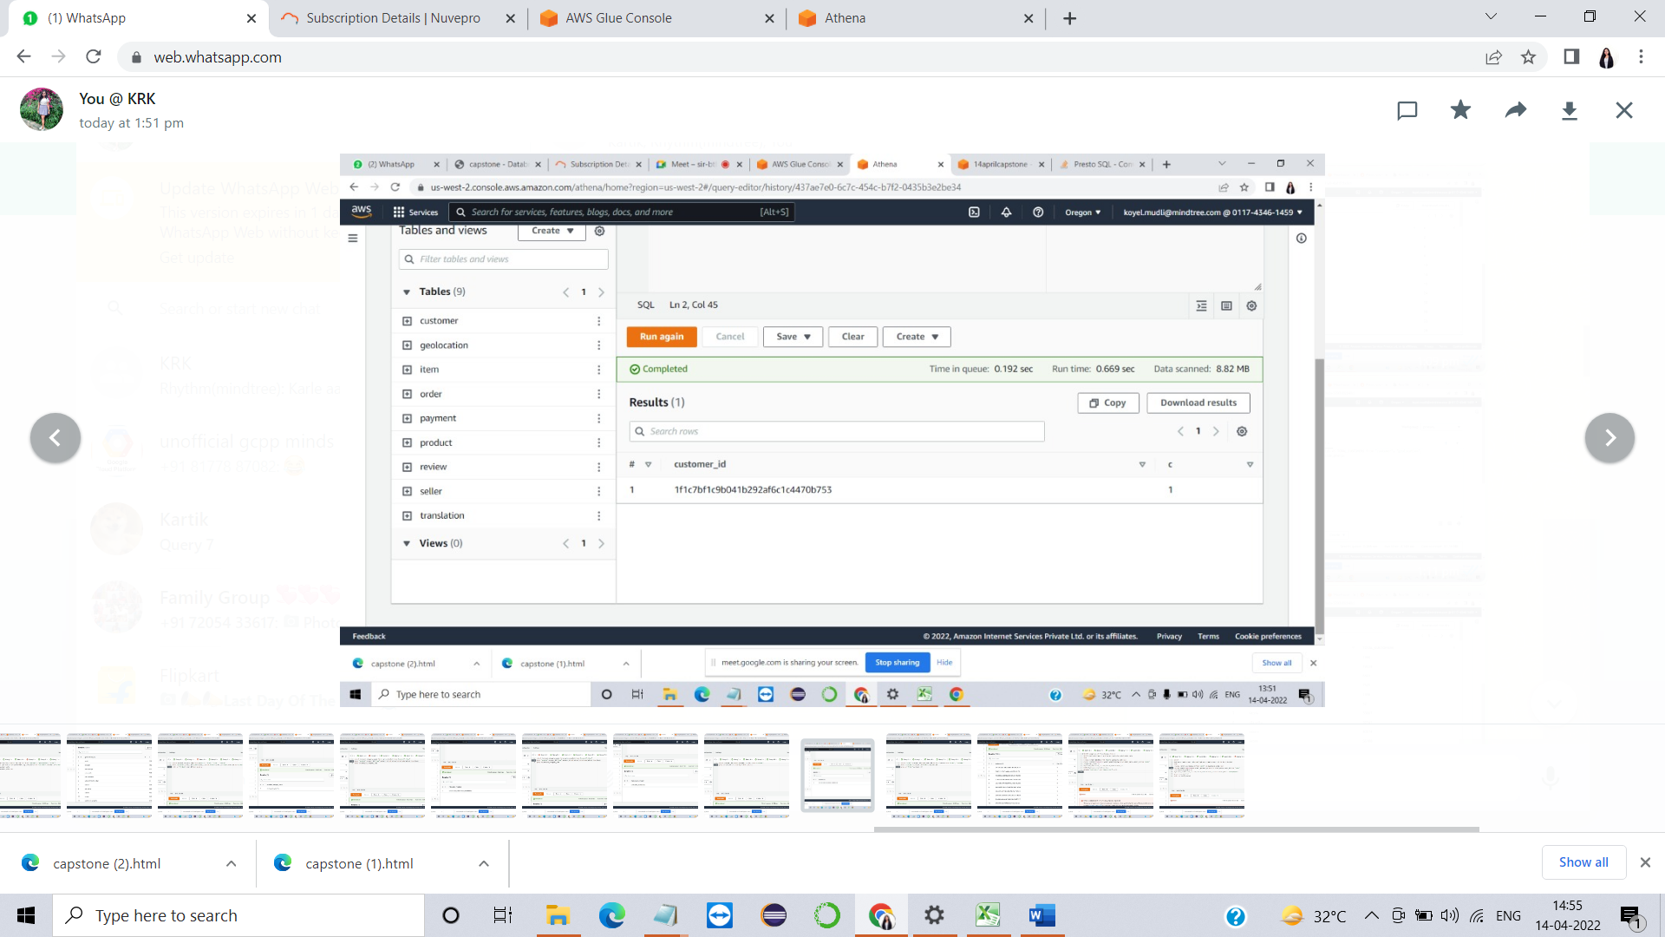

**[14]**.Show how many orders have been placed by how many customers

select "order".customer_id,count(order_id) AS No_of_orders from "order", "customer"

where "customer".customer_id="order".customer_id

group by "order".customer_id

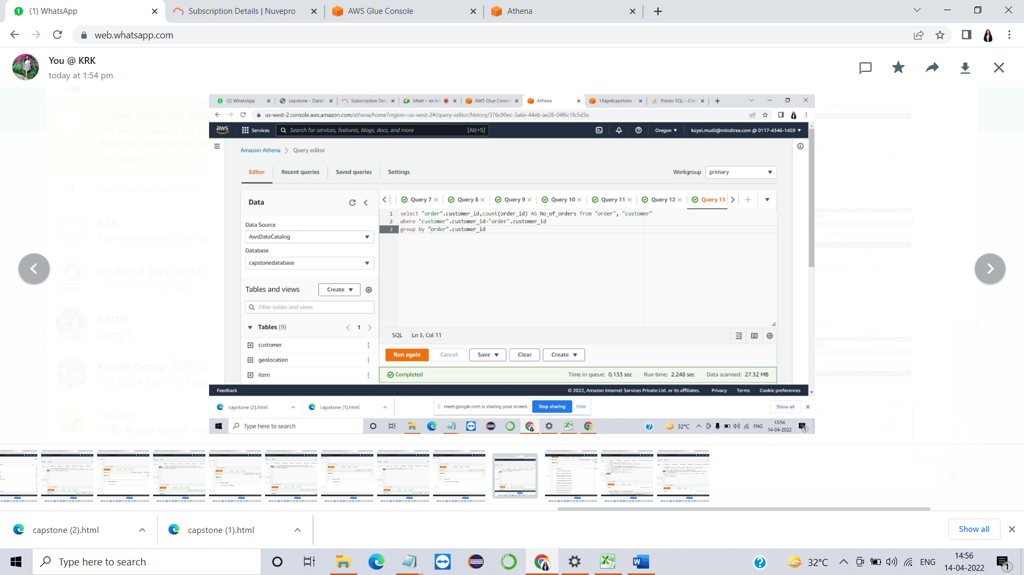

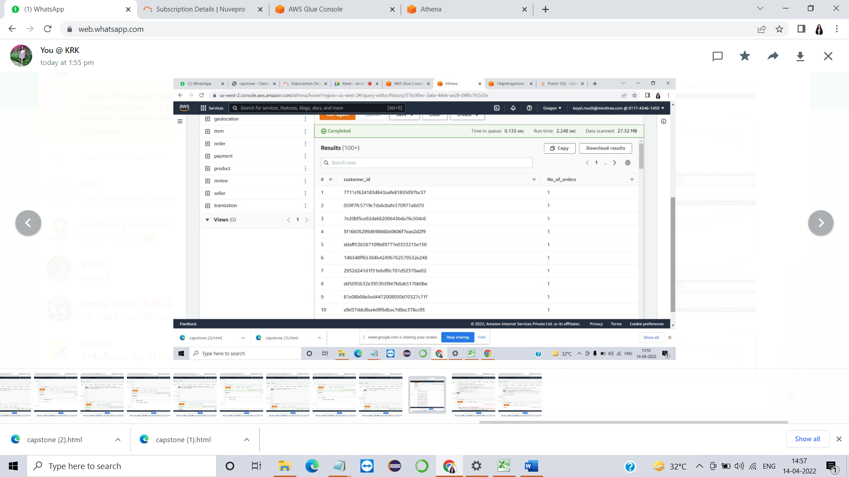

**[4].** Total Revenue generated between dd/mm/yyyy to dd/mm/yyyy

SELECT sum(price) AS Total_Revenue from (

SELECT duplicate_item.price AS price,duplicate_order2.Order_date

from

( SELECT order_id,price from "item") duplicate_item join

(SELECT CONVERT(VARCHAR(20),order_approved_at,111) AS Order_date, order_id from "order"

) duplicate_order2 on

duplicate_item.order_id = duplicate_order2.order_id

WHERE duplicate_order2.Order_date

BETWEEN '2017-05-04' AND '2019-12-30') AS TR

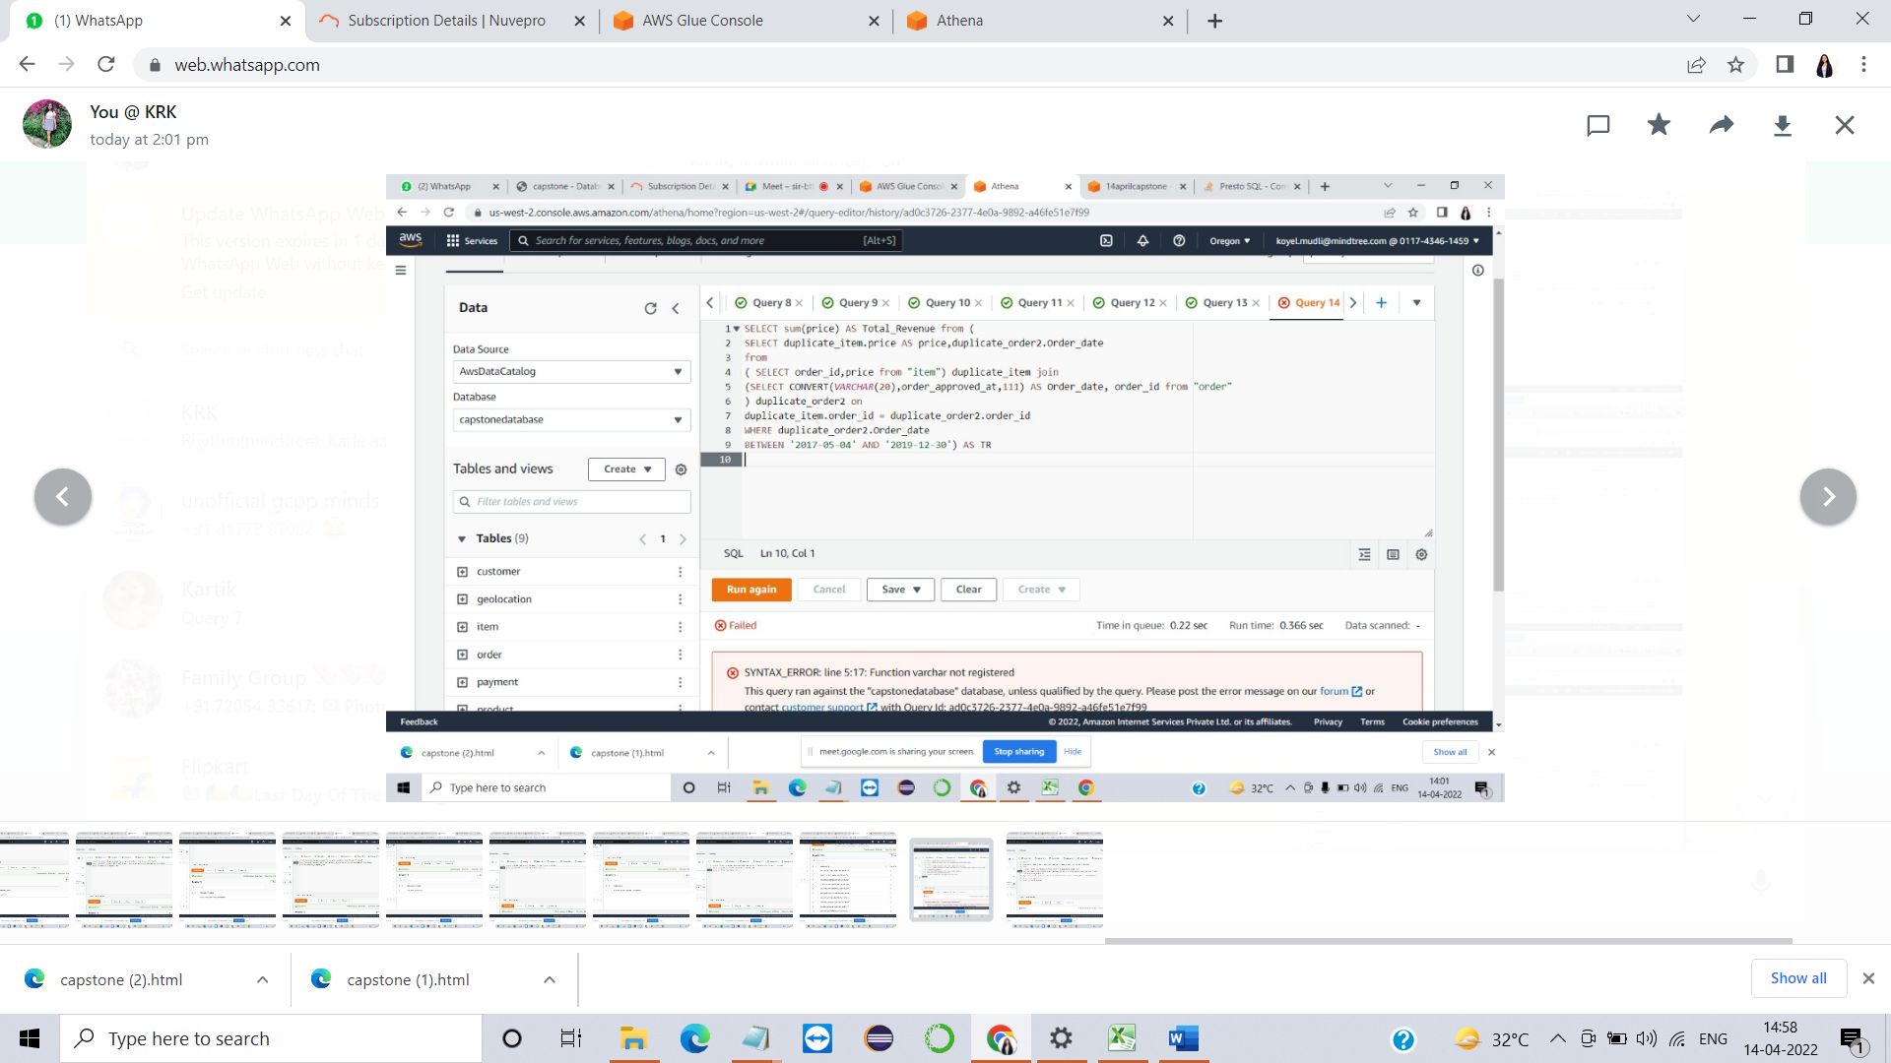

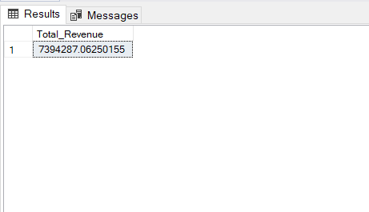

**[9].** Product sales over Time (scope of a particular product day by day)

SELECT duplicate_item1.product_id,count(duplicate_item1.product_id) AS Total_Product

from

( SELECT order_id,product_id from "item") as duplicate_item1 join

(SELECT CONVERT(VARCHAR(20),order_approved_at,111) AS Order_date, order_id from "order"

) as duplicate_order2 on

duplicate_item1.order_id = duplicate_order2.order_id where Order_date = '2017/05/04'

group by product_id

order by Total_Product

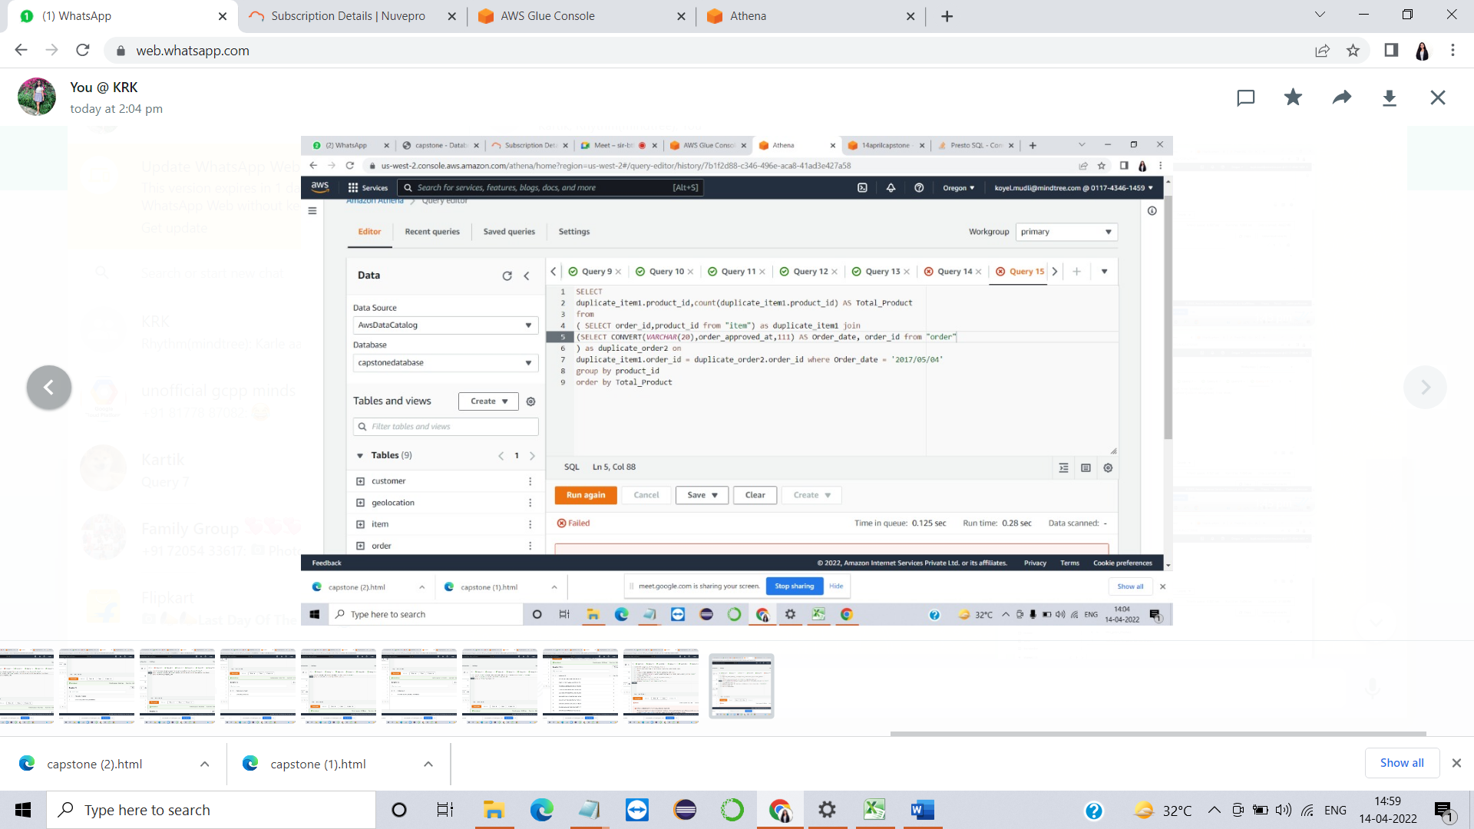

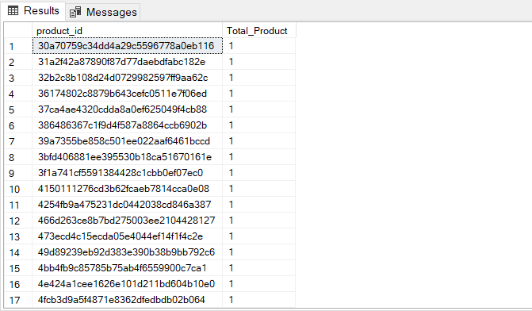

**Alternate Approach :**

we can create a job using these two tables and run the same job to save the result in a csv at our storage and later we can read the same to get our result

